**UK MODEL WALL MOUNTED FANS:**

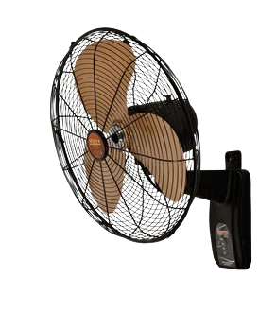

**Price: 7,850.00**

The UK Model Wall-Mounted Fan is a sleek and efficient ventilation solution, designed to provide reliable airflow while saving valuable floor space. With its robust motor and aerodynamically-designed blades, this fan delivers a strong and consistent breeze, effectively cooling small to medium-sized areas. Its adjustable speed settings, easy installation, and compact design make it an ideal choice for homes, offices, and workspaces, providing a convenient and energy-efficient cooling solution.

**Key features of uk model wall mounted fans include:**

* **Variable speed settings** (often 3) for adjustable airflow.
* **Oscillation function** for even air distribution.
* **Durable, space-saving** wall-mount design.
* **Adjustable tilt** for directing airflow.
* **Quiet operation** for minimal noise.
* **Safety grills** for added protection.
* **Energy-efficient motors** for optimal performance.